Lab Task 03
Zain jabbar (323)
AI (lab)
Q:1
Trace BFS and DFS manually on the supplied graph. Use the original A–G graph from Section 3.2 and start A, goal G. Draw or tabulate each queue/stack state, processed node and path. Follow the supplied successor order and stop on goal processing. Report the final path and visit order separately; verify your trace against the supplied BFS/DFS code.
What I did
1. This code searches the graph from **A** to **G** using two methods: BFS and DFS.
2. **BFS** uses a queue (`deque`) and explores nodes level by level.
3. **DFS** uses recursion and explores one branch as far as possible before backtracking.
4. Both functions return the nodes visited and the path found; the paths are `A → B → D → G`.
5. The `None` defaults for `path` and `visited` avoid shared mutable-default issues in `dfs`.
6. No specific error or traceback is shown, so I can’t tell which earlier error you fixed.
Code screenshot
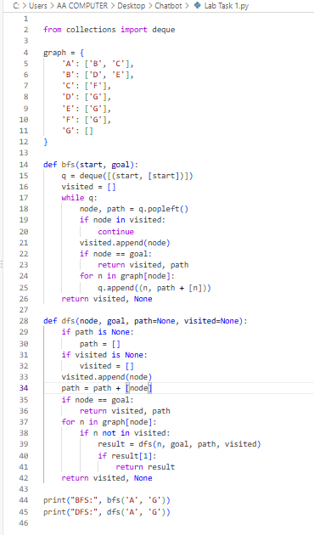
Code Explanation

- `from collections import deque` imports a queue structure used by BFS.
- `graph` stores the connections between nodes. For example, A connects to B and C.
- `bfs(start, goal)` searches level by level using a queue and keeps track of visited nodes and the path.
- `dfs(node, goal, ...)` searches down one branch recursively before trying another branch.
- Both functions return the visited nodes and the route to the goal when they find it
- With this graph and the given neighbor order, both find the path **A → B → D → G**.
Code Run Screenshot
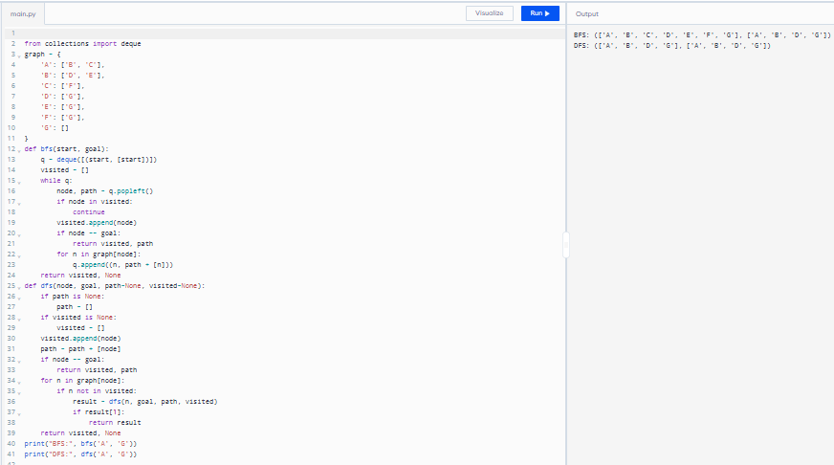
Q:2
Implement DLS and IDDFS and test limits 1, 2, 3 and 4. Use the same original graph, counting the root at depth 0. Implement a path-local cycle check and distinguish FOUND, CUTOFF and FAILURE. Run DLS at each listed limit and run IDDFS with maximum depths 1, 2, 3 and 4. Report status, path and limits attempted; explain repeated work and why limits below 3 do not succeed
What I did
1. This code implements **Depth-Limited Search (DLS)** and **Iterative Deepening DFS (IDDFS)** to find a path from A to G.
2. DLS searches recursively but stops going deeper when it reaches the specified depth limit.
3. It tracks visited nodes and checks the current path to avoid revisiting a node within that path.
4. The loop tests DLS with limits 1 through 4 and reports whether the search found the goal, hit a cutoff, or failed.
5. IDDFS repeats the search with increasing depth limits and stops when it finds G; the path found is **A → B → D → G**.
6. No error message is included, so I can’t identify a specific error you fixed; the code shown appears intended to run as written.
Code Screenshot
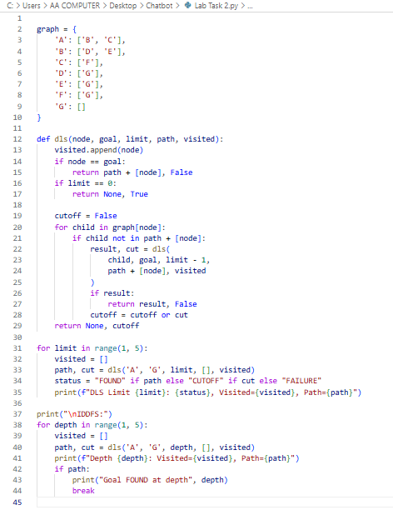
Code Explanation
This code searches the graph from **A** to **G** using **Depth-Limited Search (DLS)**, then repeats the search with increasing limits using **Iterative Deepening DFS (IDDFS)**.

- `dls(node, goal, limit, path, visited)` searches from the current node. It adds each visited node to `visited`.
- If the current node is the goal, it returns the full path and `False` for cutoff.
- If the depth limit reaches `0` before the goal is found, it returns `None` and `True` to indicate a cutoff.
- The loop `for child in graph[node]` searches each connected child, reducing the limit by one each time. The path check prevents revisiting a node already on the current route.
- The first loop tests limits **1 through 4**, printing whether the goal was found, the search was cut off, or no path was found.
- The IDDFS loop starts at depth **1** and increases the limit until it finds G. Here, it finds **A → B → D → G** at depth **3**, then stops.
Code Running Screeshot
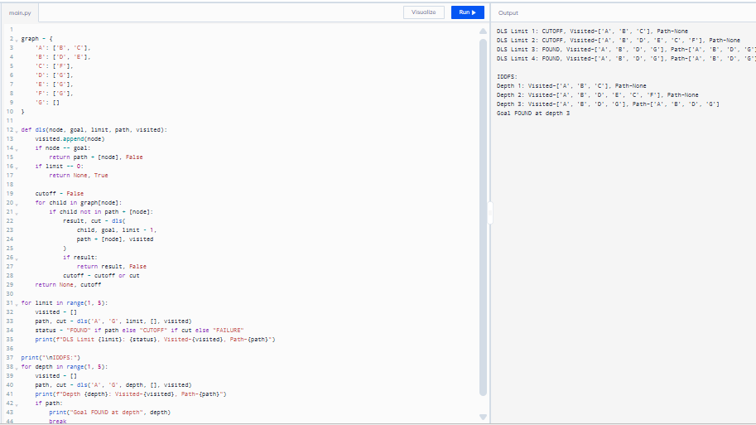
Question 3
Create a weighted version of the graph and use UCS to find the minimum-cost path. Specify every edge weight and document any added corridor. Use the controlled extension in Section 3.7 or an equivalent clearly stated weighted version. Run UCS, sum the returned path’s edge weights independently, and compare with a BFS route on the same weighted topology. Record processing order and explain why a shorter-hop route can cost more
What I did
1. This code represents a weighted graph, where each connection has a cost, such as A → B costing 1.
2. `ucs()` uses a priority queue (`heapq`) to expand the path with the lowest total cost first.
3. `bfs()` uses a queue to find a path with the fewest edges, then adds the edge costs along that path.
4. UCS finds **A → B → E → G** with total cost **7**, the cheapest route.
5. BFS finds **A → B → D → G** with total cost **11**; it has the fewest edges, but not the lowest cost.
6. No error message or earlier version is shown, so I can’t identify a specific error you fixed; the code shown appears valid.
Code Screenshot
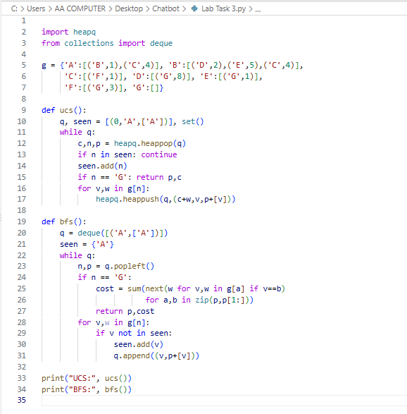
Code Explanation
This code compares **Uniform Cost Search (UCS)** and **Breadth-First Search (BFS)** on a weighted graph, searching for a route from **A** to **G**.

- In `g`, each node lists its connected neighbors and the cost of each edge. For example, going from A to B costs 1.
- `ucs()` stores candidate routes in a priority queue as `(total_cost, current_node, path)`. It always explores the route with the lowest total cost next.
- UCS uses `seen` to avoid processing a node again after it has been reached at its lowest cost. When it reaches G, it returns the path and its total cost: **A → B → E → G**, cost **7**.
- `bfs()` uses a regular queue and explores paths by number of edges, not by their costs. It finds **A → B → D → G**, which has three edges and costs **11**.
- BFS calculates that route’s cost afterward by looking up each edge in the path and adding the weights.
- So, UCS finds the **cheapest route**, while BFS finds a route with the **fewest edges**; those routes don’t have to be the same.
Code Running Screeshot
